# 1/10/2023 Math Review:

* All functions in real numbers
  + 
  + Limits: 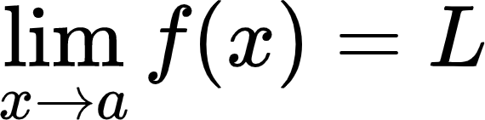
    - (what happens as we approach the value)
    - For all 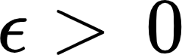, there exists a 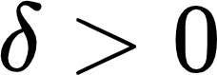. 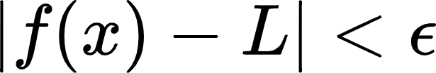 when 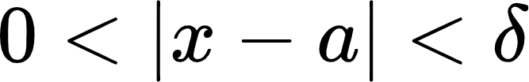
    - {"backgroundColor":"#ffffff","backgroundColorModified":false,"id":"7","code":"$$\\epsilon$$","font":{"family":"Arial","size":11,"color":"#000000"},"type":"$$","aid":null,"ts":1673366953770,"cs":"Id8KI8wffi5uY+783Mjq6A==","size":{"width":5,"height":6}} = error tolerance, 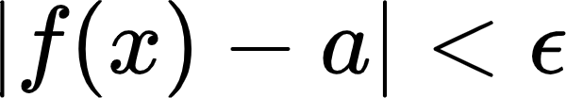
* Most functions will be considered continuous for this course
  + 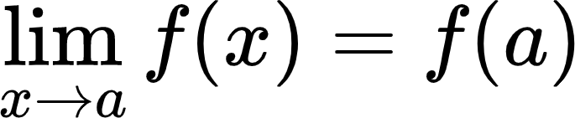
* Derivatives - slope of the tangent line at a given point
  + A function that is differentiable is automatically continuous
  + 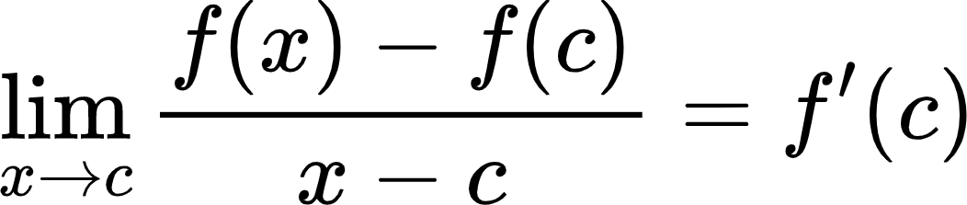
  + 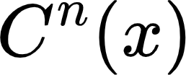 - Set of all functions that are n-times differentiable on the set x .
* Intermediate Value Theorem - If f is continuous on [a, b], then there exists some c{"code":"$$\\epsilon$$","font":{"color":"#000000","size":11,"family":"Arial"},"backgroundColor":"#ffffff","type":"$$","backgroundColorModified":false,"aid":null,"id":"13","ts":1673367771526,"cs":"C+xsxcvfjAVJZ2JYuq371g==","size":{"width":5,"height":6}}[a, b] such that 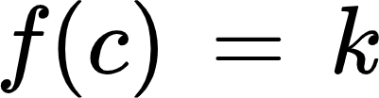 for any k between 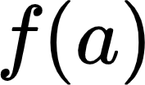 and 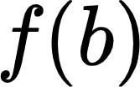
  + 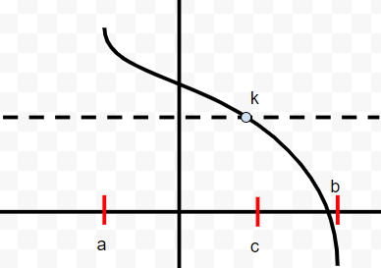
* Mean Value Theorem - If f is in 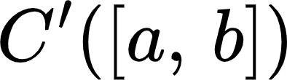, then there exists some c in [a, b] such that 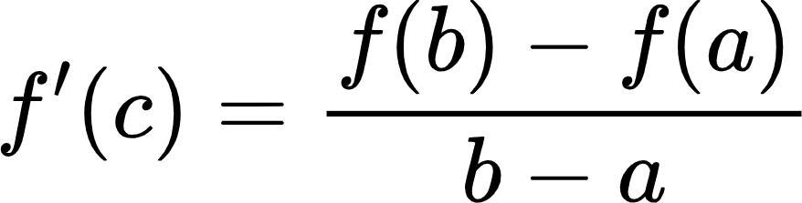
* Taylor’s Theorem - f is in 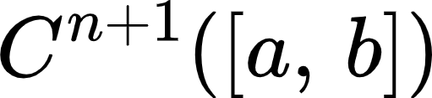 and {"id":"20","backgroundColorModified":false,"code":"$$x_{0}$$","backgroundColor":"#ffffff","aid":null,"type":"$$","font":{"size":11,"family":"Arial","color":"#000000"},"ts":1673368291280,"cs":"+J2xegBZE7Chz0MjyXb3tQ==","size":{"width":14,"height":9}} is in 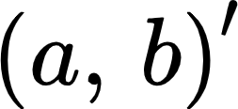, then for all x in (a,b), 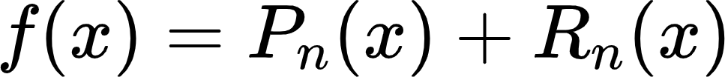, where 
  + Remainder: 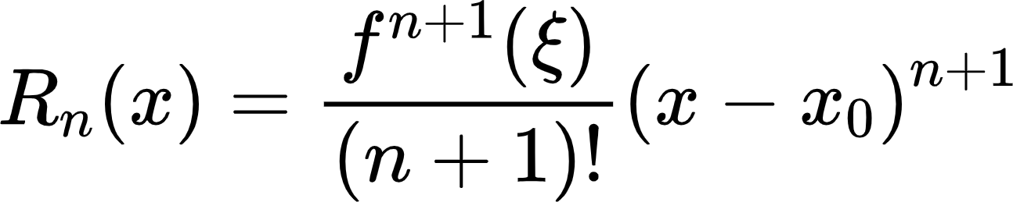
    - {"font":{"color":"#000000","size":11,"family":"Arial"},"id":"25","aid":null,"backgroundColor":"#ffffff","backgroundColorModified":false,"code":"$$\\xi$$","type":"$$","ts":1673368633306,"cs":"BtL+HGS9fiefb5Y/2wjZJw==","size":{"width":6,"height":14}} = “ksigh”
    - For some {"font":{"color":"#000000","size":11,"family":"Arial"},"id":"25","aid":null,"backgroundColor":"#ffffff","backgroundColorModified":false,"code":"$$\\xi$$","type":"$$","ts":1673368633306,"cs":"BtL+HGS9fiefb5Y/2wjZJw==","size":{"width":6,"height":14}} between x and 

# 1/12/2023